- \Operation\Carton ejection\Carton ejection
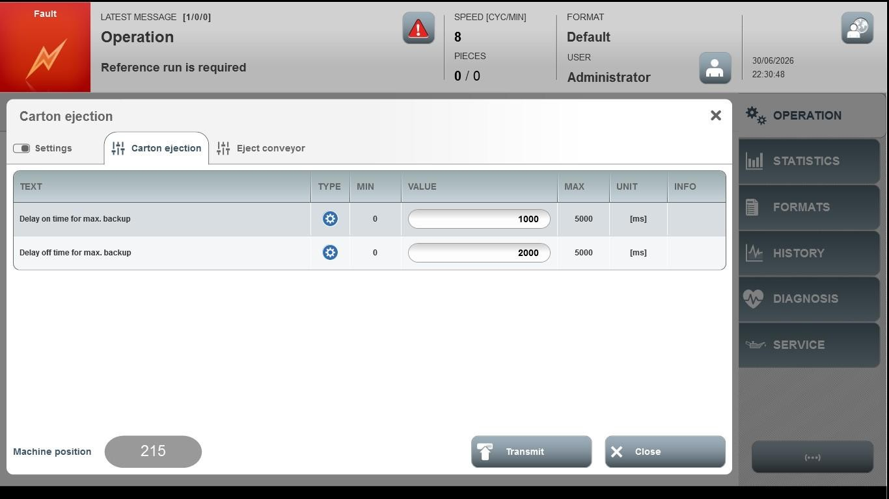
Acceptance criterion | Limits | Pass / Fail: Dev-No. | Date | Initials
Screen matches screenshot | N / A
Delay on time for max. backup | 0 … 5000
Delay off time for max. backup | 0 … 5000

